For Now I am

LX Focus Notes

Chanel Number | Lantern | Colour | Note
1,2,3 | Fresnel | Lee 201 | D/S Wash
4,5,6 | Fresnel | Lee 201 | Mid Wash
7,8,9 | Fresnel | Lee 201 | U/S Wash
10,11,12,14,15,16,18 | 36 Degree Profile | Lee 201 | Shines  Hard sharp focus.  Position lantern as low as possible (in Tramway off sprung Floor) so shutters are nearly touching floor. In Tramway this will mean that the nose of the lantern is only just above the raised sprung dance floor.  Open out shutters to make a circle of light on the opposite wall to start, bring in the top shutter to clip the lower edge of the beam of light so that it is close to the mid point of the beam, then crop in sides and top to make a widest square or rectangle as possible.  This should ensure the beam of light has a flatter edge as possible and does not open out too much vertically as it crosses the stage. As it’s a fine point to ensure there is no light on stage and yet still get Marc’s fingertips when he is lying flat on the floor. Use a reference point on opposite walls such as the black or silver pipes in Tramway to keep all lanterns at the same size. Trim down stage edges to ensure there is no spill onto D/S edge of D/S legs or of wall and no spill onto U/S black tabs.
17 | 36 Degree Profile | Lee 201 | As above but 17 has 2 x profiles next to each other on the same bar. This is to give maximum coverage from mid stage to upstage from this point. In smaller venues just a single lantern is likely be required.
19 + 20 | 36 Degree Profile | O/W | Set at 8ft high in line with the rigging point.  Very sharp focus as a thin blade (in the presence of haze) horizontally across the stage. This is to hit Marc across mid chest and shoulders when he is hanging upside down. Trim off upstage tabs / wall. To ensure the horizontal lines match up to make one continuous sheet of light across the stage, try to focus the line of light into the middle of the partnered light on the opposite side of the stage. The line should be approximately 5cm thick by the time it hits the lens of the profile on the opposite side of the stage. A fixed angle profile will produce a cleaner line than a zoom for this. Once focused check in the presence of a strong haze and in black out that these lines look as if they merge into each other seamlessly.
21 | This can be a 15/30 or 36 Degree profile but to be the same as 24 & 35 | O/W | Box 1  A box measuring 2.10 x 2.10  (note this box will need to be made bigger in next focus session – to allow Marc to roll from centre point and still have enough room to reach to on stage and down stage edges whilst still being in the box of light. The onstage edge and down stage edge should be expanded. The positions of 21 & 22 will need to be tweaked to accommodate this.  Hard sharp focus.  In tramway this was set 1 strip of dance floor from the front of the stage – this was the set up in Tramway but may need to be adjusted in other venues to ensure there are clear sight lines of Marc when on the floor at the front of the box at this point. If need be move upstage until Marc is clearly visible from all seats.  The front edge of the box should be on the same line as Box 2 (Lantern 24)  It should also be noted that the box should be in a position where Marc can be illuminated by the side booms well.  Spike place 0.95m from front of box upstage and central – this marks position for Marc’s head on set up. This can be made with black tape as Marc will get into position before the house opens with lantern number 23 up so that alignment of head and body will be correct.
22 | 26 | O/W | This is a very small box located within Box 1 used to just used to illuminate Marc’s left hand.  30cm x 30cm just off hard focus.  Positioned 1.15m from front of the box and onstage stage right edge 60 cm from middle of Box 1. But its best to check this with Marc in position.
23 | 36 | O/W | Line 1  Hard Sharp Focus.  Aligned with downstage edge of Box one and extending upstage 3m from that point and 15cm wide.  This is a strip of light cutting through the middle of Marc’s body and is to extend upstage of Box 1.
24 | This can be a 15/30 or 36 Degree profile but to be the same as 21 & 35 | O/W | Box 2  A box measuring 2.1m x 2.1 m Sharp focus.  Positioned down stage, just to the Stage right of Centre, with the stage right edge of the box roughly in line with the centre line and set 1 strip of dance floor from the front of the stage – this was the set up in Tramway but may need to be adjusted in other venues to ensure there are clear sight lines of Marc when on the floor at the front of the box at this point. If need be move upstage until Marc is clearly visible from all seats.  Marc found it helpful to have a spike on the down stage cetre edge of this box.  It should also be noted that the box should be in a position where Marc can be illuminated by the side booms well.
34 | 36 Degree Profile | OW | This is a long strip of light that runs from mid stage measuring 5.3m leading directly upstage, 18cm wide.  2.75 m from mid stage point. In the Tramway the downstage edge was in line with the down stage edge of the S.L mid stage wall the cuts into the performance space.  Note there is a spike on the down stage central point and 80 cm in from the upstage edge.  Hard sharp focus.
35 | This can be a 15/30 or 36 Degree profile but to be the same as 21 & 24 | O/W | Box 3  A box measuring 2.1m x 2.1 m Positioned with its upstage edge in the middle of the position the rigging comes down to on stage.  Hard sharp focus.  Marc found it helpful to have a spike up stage center of this box.
36 | 36 Degree Profile | O/W | Another thin line with a sharp focus 15cm wide when it hits stage.  Positioned directly overhead of the middle Box 3 to cast a line from upstage to downstage through the middle of the box. This should match up with Lantern 37 to make a seamless continuation.
37 | 26 Degree Profile | O/W | This has a similar focus to 19 + 20 just a vertical version instead of a horizontal position. To be set as far back in the venue as possible to throw over the heads of the audience as much as possible – if in a large venue and there is enough throw a 19 degree could also be used.  This will draw a line vertically up through Marc during his lift. The bottom of the line needs to just touch the floor at the point the rigging touches the floor to ensure there is no black moments in the middle of Marc between him leaving the floor to being elevated – plus to line up with the overhead line (lantern number 36) this is marked in the spacing diagram as a strip which extends from stage up the back wall, and from upstage to approximately the middle of box 3 – again this needs fine tuning once rigging has been tested with Marc.  The line needs to extend vertically a comfortable distance above Marc’s feet when fully elevated and ideally up to the grid.  Width of line as it hits Marc = 15cm
38 | 36 Degree Profile | O/W | This lantern has not yet been used and so is not in the current lighting plot / show file. It will need to be added and ideally put on a sub for spaces where rigging will happen – as a back up in case the rigging fails. Or can be entered into the lighting plot in place of lanterns 19 & 20 for spaces where rigging may not be possible.  This will form another thin line just like lantern 36 but instead be focused across the stage directly above Marc’s mid chest and outstretched arms when laid back in Box 3. This will be approximately 1.1m from front edge of box. If there is not a bar in this exact position its better to rig the light slightly upstage rather than down stage.
N.B. Lanterns 22,21,34,36,37 need to be in line with where they are going to hit on stage so that the beam of light travelling through the haze and space so that these lines of light are perfectly vertical.

Shin Focus

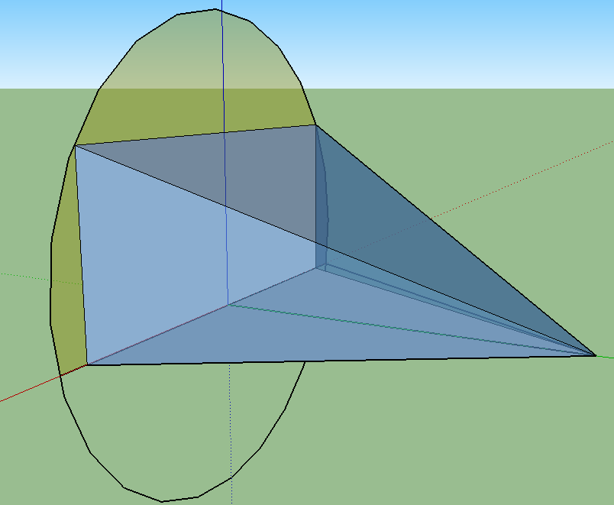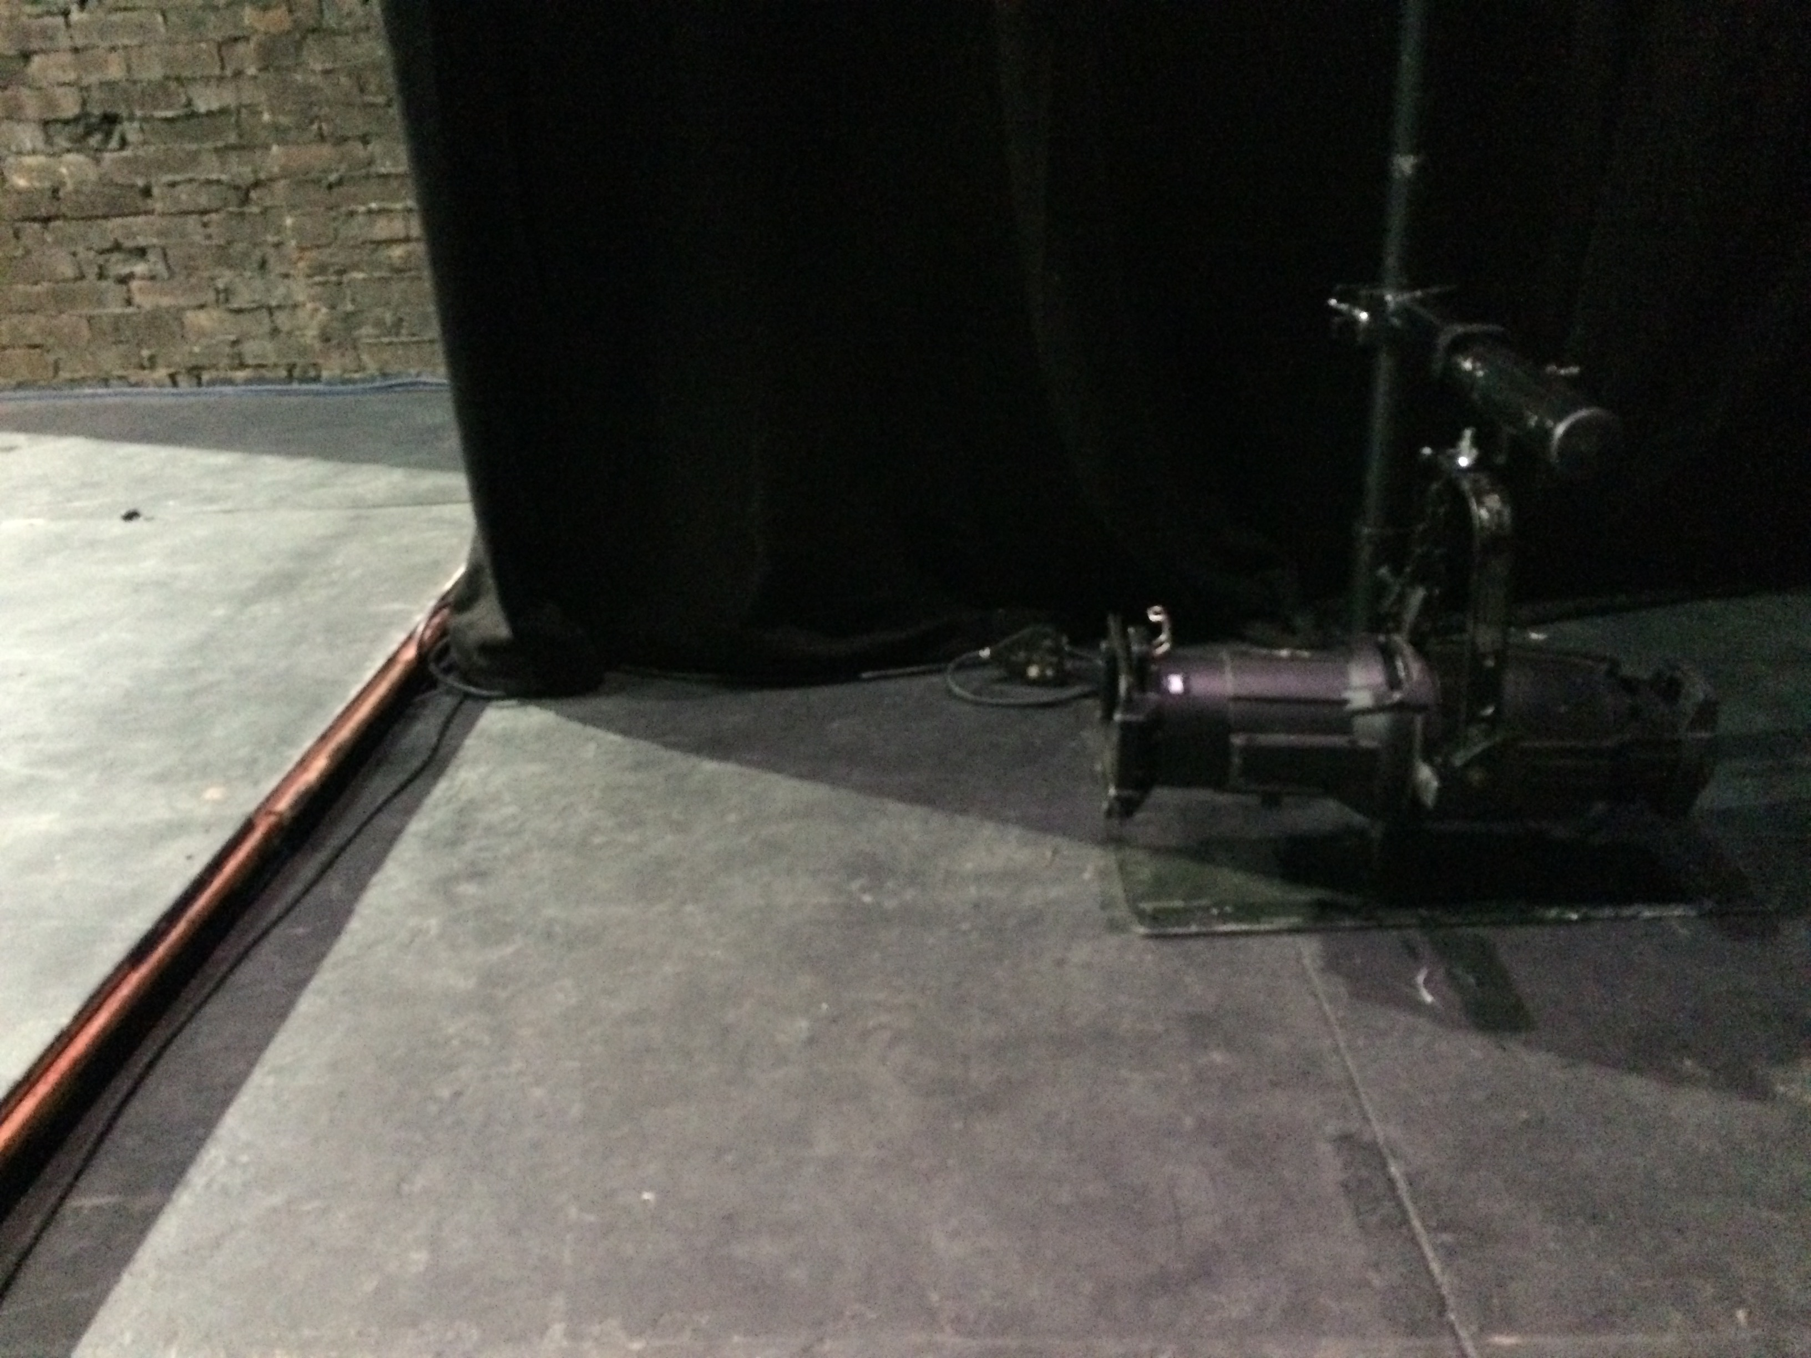

Box 1 and associated lights

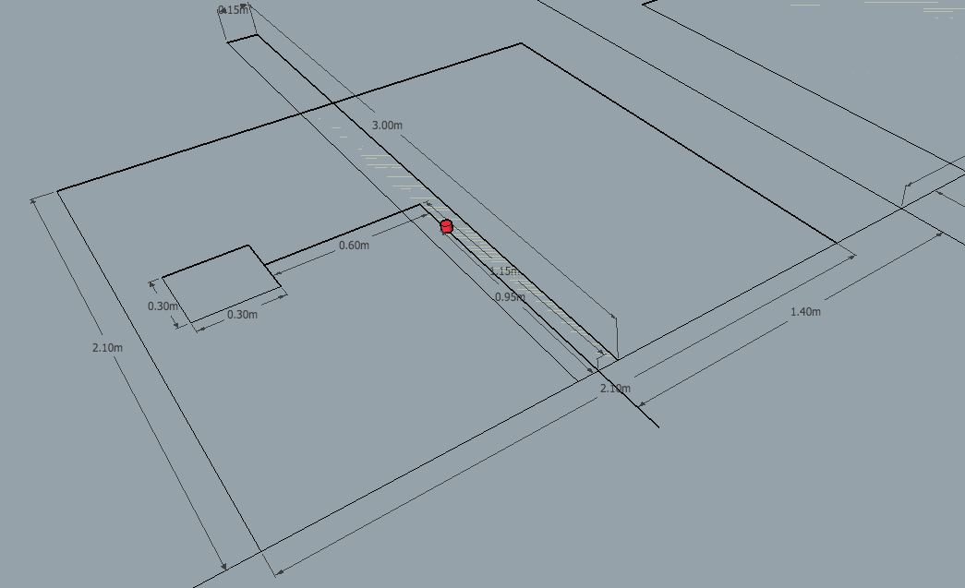

Box 2

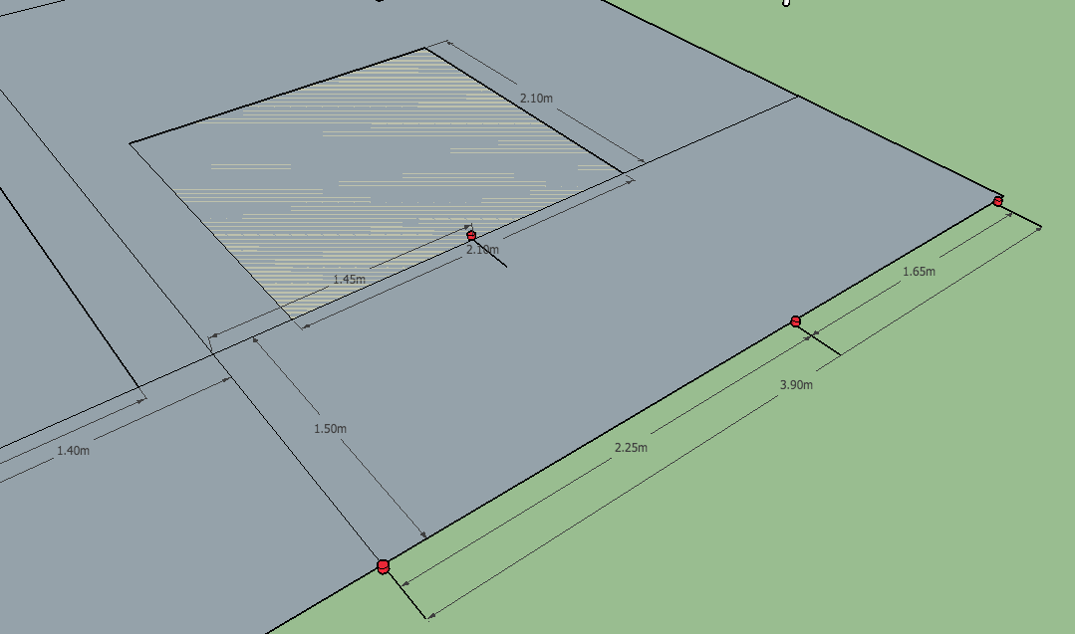

Box 3

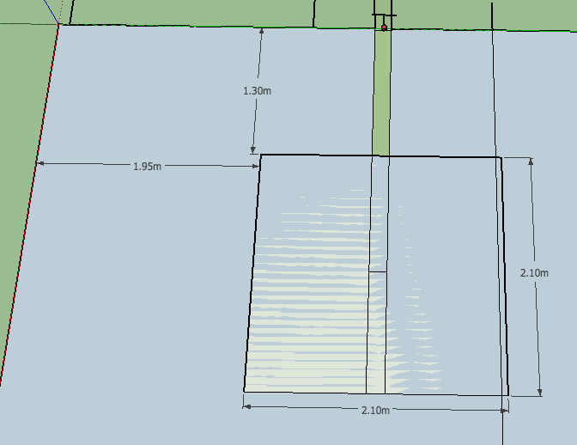

Stage Left Strip

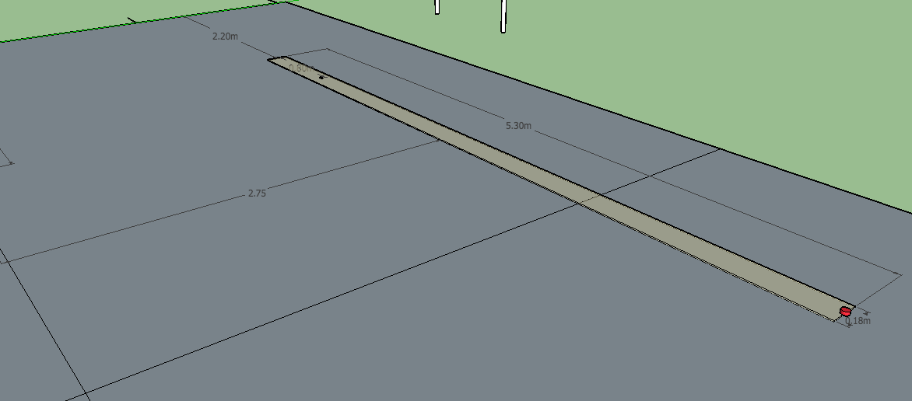

Over View and Boom Spacing

