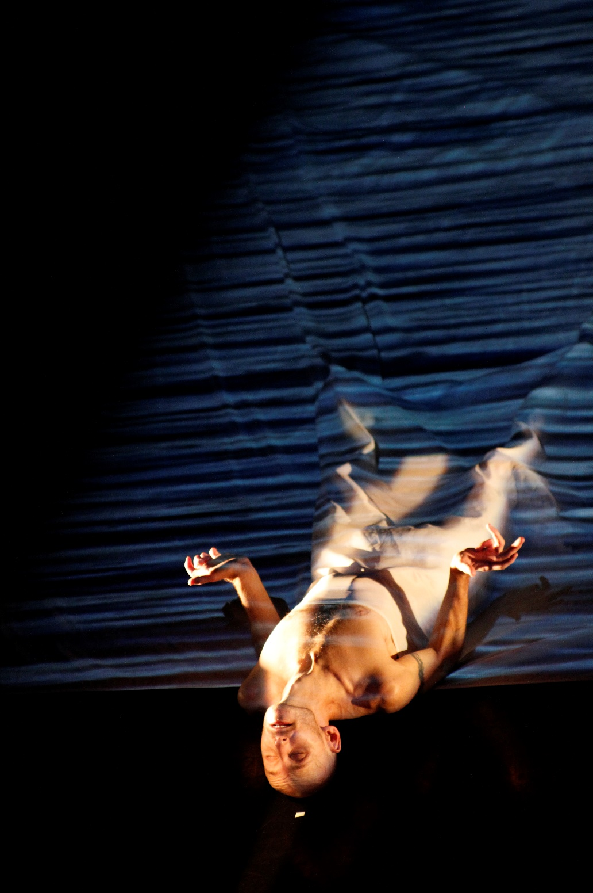

For Now, I am Tour Spring 2015
Box Office Briefing

Box Office Briefing Sheet
Running time:
Remember When 10 mins
Uath Lochans 5 mins
Interval
For Now, I am 40 mins

Age recommendation: We recommend this programme for ages 12+. There is no specific adult content in the work but the company feel that under 12’s may struggle to concentrate for the whole programme however we would welcome any under 12s that wish to attend.

Warnings: There are no specific warnings for this programme but audience members may wish to note that For Now, I am uses haze and Marc will appear with bare chest and legs.

Who is Marc Brew?

Marc Brew is an Australian performer, director and choreographer. Now based in Glasgow, Marc has produced his own work that has been toured to critical acclaim across the world. His outdoor work (i)land being commissioned for the Glasgow 214 Cultural programme and Without Walls. Marc has also produced work for a number of high profile companies such as AXIS Dance Theatre (USA), Candoco Dance Company, Scottish Dance Theatre, Touch Compass (NZ), Amy Seiwert’s Imager (USA), The London Contemporary Dance School and YDance.

Why should people come to this show and take a chance on contemporary dance / dance theatre?

- For Now, I am… is a multimedia work layering dance, specially commissioned music and video projections.
- An opportunity to see work produced and performed by an internationally acclaimed artist.
- Great storytelling. See how dance can tell Marc’s journey, from
his past as an elite ballet dancer and his body as it is now, since his car accident in 1997.
- See Uath Lochans, a short film made by award winning dance film makers Simon Fildes and Katrina McPherson in which Marc performs in the Cairngorm mountains in Scotland.
- Keep up with the creative and rehearsal process and the tour by following Marc on facebook and twitter.
- Worried you’ll not understand it? Some dance theatre has a narrative/story and some does not, each piece can mean something different to different people, to the dancers and to the choreographer. This type of dance is very much in the eye of the beholder – there are no wrong answers! If you don’t think you understand what’s going on - Don’t Worry, just sit back and watch a dancer and storyteller at the top of his game
- Surprise yourself with something new!

Want to find out more?
More information about the work and the company can be found on our website, www.marcbrew.com
You can see clips of Marc’s work, past and present on vimeo.com/user6316423
youtube.com/MarcBrewCompany
and can keep up to date or send us feedback at facebook.com/MarcBrewCompany and twitter.com/marc_brew
Latecomers
The Company would prefer to not allow latecomers after 5 minutes into the show
Access
There is no spoken word in this programme.
Large print and audio versions of our programmes will arrive with the company and are available on the website www.marcbrew.com
Where are we touring?
Tramway, Glasgow as part of DIG festival – 26 & 27 May (For Now, I am)
Cumbernauld Theatre – 28 May (Triple Bill)
The Brunton Musselburgh – 29 May (Triple Bill)

Marc Brew Company will also be performing at the 2015 Edinburgh Festival Fringe. Please see the website for updates.

