The evening's honours belonged to Marc Brew. Brew's precise duet exuded a rough sensuality. Its stirring, succulent ambiguities arose out of the clarity and strength of the performers.
Donald Hutera, The Guardian.
1 / 15
For Now, I am…
Choreographer: Marc Brew
Designer: Marc Brew
Dancer: Marc Brew
Reviewer: Stephanie Whitelock
The world premiere of Marc Brew’s latest work did not disappoint. Following on from previous work that depicts his past as an elite dancer, Brew’s latest piece For Now, I am… is the story of the transformation he has had to face after a life-changing car accident.
Mesmerising, phenomenal and haunting are only a small selection of worthy superlatives that can be used to describe Brew’s performance. With faultless and elegant choreography clearly narrating the story of Brew’s changing body, it is evident Brew’s background is in ballet as every move he makes is done so in a flawless and classically beautiful way.
The lighting, score and staging all complement one another, making the flow of the performance effortless and surprisingly calming. Utilising the whole stage in the most graceful of ways with only a large white sheet as company, Brew seemed to be at one with the music. At times it seemed that the music was at one with him.
In parts, one is left breathless by the intimate story that Brew is sharing. Moving and touching, Brew’s world premiere is magical throughout. The audience were hooked from the beginning with many leaning forward in their seats, engrossed in Brew’s storytelling from the start. It was apparent in the hushed tones after a well-deserved applause how in awe Brew had left his audience.
It is obvious the calibre of talent that Brew exudes during his performance and his work ‘For Now, I am…’ is nothing short of spectacular.
For Now, I am… is most definitely a powerful and inspiring piece of dance that will stay with you for years to come.
Reviewed on 26 May 2015
Review Overview
The Public Reviews Score *****

World Class
Article source: http://www.thepublicreviews.com/marc-brew-for-now-i-am-tramway-glasgow/

Dance review: For Now I Am
Choreographer and solo performer Marc Brew presents a striking expression of narrative dance
- Source: The List
- Date: 27 May 2015
- Written by: Gareth K Vile
Both through his own company, and in collaboration with Scottish Ballet, Marc Brew has established his credentials as a bold choreographer for ensembles. His acute awareness of the potential hidden in the combination of disabled and ballet-trained dancers gives his work a distinctive identity, reconciling the lyrical elegance of ballet with a contemporary dynamism. In For Now I Am, however, Brew has made a solo that examines his experience as a performer, a companion piece to Remember When, which recalled memories from before the car accident which changed his life, and body.

Jamie Wardrop's sensitive projections surround Brew's prone body with flickering images of water: drawing attention to the dancer's body, Brew uses an immediate and clear physical vocabulary to reveal his periods of doubt, recovery and spiritual regeneration. The motif of water, echoed in the musical score, suggests healing but also isolation, with Brew variously laid out on a beach and perched at the edge of a pool. Without becoming too obvious, For Now I Am moves through moods and emotions, as he comes to terms with his new situation.

With his head shaved, and upper body exposed, Brew is wrapped in a large sheet, before emerging as if from a chrysalis. The episodic structure takes the journey from his initial recognition of an injured body, through acceptance and testing his new form, before concluding with an ambiguous and dramatic finale, leaving Brew literally hanging from the ceiling. While it is explicitly based on his own experience, Brew abstracts it through dance, presenting a story that is familiar in its rhythms of despair and triumph. His genius is in being able to connect his life to wider concerns, and his biography becomes a symbol of life's challenges.

Rooted in Brew's raw physical presence, For Now I Am is nevertheless a spiritual choreography, that becomes a gentle meditation on suffering. Melancholic, yet passionate, it is a striking expression of narrative dance that is imaginative and thoughtful.
Reviewed at Tramway, Glasgow, Tue 26 May.
- Article Source: https://www.list.co.uk/article/71175-dance-review-for-now-i-am/

Arts:Blog
Dance Review: Purging Suite #1/For Now, I Am...
POSTED BY ACROSS THE ARTS ON MAY 28, 2015, AT 7.15AM

Lorna Irvine reviews a double bill from Dance International Glasgow.
For Now, I Am... ****
Marc Brew's haunting For Now, I Am... is almost too fragile to watch. A large sheet like an ocean engulfs Brew's prone body. Jamie Wardop's stunning projections ripple like aquatic patterns.
He is entirely covered, as with a shroud, before tentatively emerging. Referencing the car accident which changed him eighteen years ago, Brew's circular arm movements and gripping of his spine are heart-rending to observe, as though relearning his body, mapping the unfamiliar changes.
Yet he stands erect, defiant, gathering the entire sheet around him like a religious costume, before 'awakening' suspended by his feet.
An emotionally-charged, personal journey of incredible beauty. The ethereal soundtrack by Andrew Huggan and Claire McCue is also gorgeous.
Part of this year’s DIG Festival.
Article Source: http://www.acrossthearts.co.uk/news/artsblog/dance-review-purging-suite-1for-now-i-am/

Marc Brew : For Now, I am ****
Tramway, Glasgow

That Marc Brew is a sensitive, intelligent choreographer, and compelling performer is increasingly a matter of fact. Less appreciated, maybe, is his ability to bring together great partnerships. Ironically, despite For Now, I am being Brew’s most personal work to date, his new solo proved that more than ever.

Lying beneath an enormous white sheet, reminiscent of the hospital bed Brew spent months in following a life-altering car crash in 1997, his body is motionless for a considerable time. What sustains us, is Andy Hamer’s lighting design, Claire McCue’s original score and Jamie Wardrop’s projected visuals – all of which deserve a name check every bit as much as Brew.

When he emerges from the material, there is a sense of him being re-born – given another chance at life, albeit with a body that operates differently from before.
Fingers, hands, arms, chest are checked to see how they move, what they can still do. All of which Brew went through in real life, adding an inescapable layer of poignancy to this work – but his choreography, execution and staging stand alone in their own right, regardless of the biographical backstory.

KELLY APTER
Article Source: http://www.scotsman.com/what-s-on/theatre-comedy-dance/dance-reviews-tamsyn-russell-marc-brew-1-3788753

Friday 29 May 2015
Dance
For Now, I am...
FIVE STARS
Tramway, Glasgow
Mary Brennan

It's 18 years since a car accident changed Marc Brew's life, his body and his burgeoning career as a classical ballet dancer. He left hospital in a wheelchair, altered but still fierce in his determination to be a maker of dance - his global success as a performer, director and choreographer is witness to his drive, his talent. This new solo, For Now, I am... is an unflinching statement of the self he wakes up with every day. It's not the chipper Marc Brew that we know from foyers and first nights. This is a (literally) naked, graphically exposed man who confronts his disability and, in coming to terms with it, creates a work of harrowing beauty and luminous, life-affirming spirit.

Thanks to a superb use of lighting and projections, the piece has a compelling element of art installation that turns the entire white floor-cloth into a monochromatic landscape, or increasingly into a seascape where surging waves are echoed on the soundscore. When Brew - whose upper body retains a lyrically articulate grace - slowly emerges from these birthing-ripples, it's in a slow awakening of fingers, wrists, elbow joints. A gradual flexing and testing, where Brew's dawning awareness is further expressed through Claire McCue's new composition for piano and cello - the latter is like his own, inner voice.

He rocks and ratchets, coiling the cloth round his lower (immobile) limbs until he looks like a merman, a mythic creature of air and water who nonetheless can't walk on land. Finally, Brew pushes himself further and is hoist, feet first, like a piece of meat, offering us the explicit truth of his body. Not asking for pity, but - as his arms take flight, like wings - owning his reality and his ability to transcend it. Words like "brave" and "risk-taking" are eclipsed by Brew's performance, which comes to Zoo Southside, Edinburgh from August 22-30.

Article Source: http://www.heraldscotland.com/arts-ents/stage/dance-reviews-an-invitationpurging-suite-1for-now-i-am-at-tramway.127396942

Marc Brew: Exalt – Tramway, Glasgow
Posted: 27/04/2015
Choreographer: Marc Brew in collaboration with the company
Direction: Marc Brew
Music: Nils Frahm
Reviewer: Lauren Humphreys
In this world premiere of Exalt, Marc Brew has created an exceptionally emotive, eloquently choreographed, ultimately uplifting piece of work.
Choreographed in collaboration with the dancers of Scottish Ballet and inclusive dance development company Indepen-dance who provide opportunities for people with a diverse range of abilities, this is a joyous celebration of movement: challenging our pre-conceptions about who can be labelled a ‘dancer’ and demonstrating just what those without rigorous formal training can achieve.
To a sonorous score by Nils Frahm, the two companies seamlessly blend to create an hypnotic and involving work. The solos, group and whole ensemble sequences demonstrate an inventive and original range of movement, expertly matched to the requirements of each dancer.
I defy anyone who sees this not be entranced. It is a piece that firmly cements Marc Brew’s reputation as one of the world’s finest living choreographers.
Reviewed on Fri 24 Apr 2015 as part of Dance International Glasgow festival
Review Overview
The Public Reviews Score - 41/2 STARS - Breathtaking
Article Link: http://www.thepublicreviews.com/marc-brew-exalt-tramway-glasgow/

Dance review: Scottish Ballet: Exalt, Glasgow
The Scotsman
KELLY APTER
Sunday 26 April 2015
There are many reasons to fall in love with a piece of dance – the performers, the choreography, the staging. Marc Brew’s new work for Scottish Ballet gives us all that, topped with something even more special: humanity.
Scottish Ballet: Exalt & 5 Tangos - Tramway, Glasgow
* * * * * 5 STARS
Exalt is a coming together of integrated contemporary dance company Indepen-dance 4, freelance dancer and wheelchair user Suzie Birchwood, and 18 dancers from Scottish Ballet. It would be reductive and patronising to suggest the sheer act of bringing performers of different disciplines and abilities together makes for moving and fascinating viewing, but I’ll hold my hands up to that. There is something genuinely moving about the egalitarian, homogenous way Brew has created a movement landscape in which everyone is equal.
Pushing all that to one side, however, Exalt is a work bursting with exciting choreography. Four free-standing ladders climb the air in each corner of the stage, used to athletic affect by distinct teams of dancers. An electronic/classical score by German composer Nils Frahm becomes a powerful force for change, as the work slips from tender to exhilarating.
Brew featured in a short, pre-show film (beautifully shot by two Scottish Ballet dancers), whizzing around the studio in his wheelchair – a chance for the audience to see the man behind the magnificent movement.
Article Link - http://www.scotsman.com/what-s-on/theatre-comedy-dance/dance-review-scottish-ballet-exalt-5-tangos-glasgow-1-3755095

Dance Reviews: Dance International, Glasgow
Mary Brennan
Sunday 26 April 2015
Scottish Ballet, Tramway Glasgow
FOUR STARS
If the new-minted Dance International Glasgow (DIG) has a vision of dance for all, then the season's opening weekend was a spirited and inspiring beginning. Scottish Ballet joined forces with integrated company Indepen-dance 4 in Exalt, a new choreography by Marc Brew that celebrated individuality even as it brought all the dancers - including a wheelchair user and adults with learning difficulties - into a final, thrillingly synchronised ensemble. On a bare stage, flanked by four rafter-high ladders, twenty or so dancers in brief body-suits - some black, some blue - explored the joys and challenges of movement to the rippling, looping rhythms of Nils Frahm. There were phrases of precise articulation, where limbs revelled in details of flexibility, trios and duets where counterbalances tested the different strengths of stand-alone endeavour and supported aspirations. As the various aspects of Brew's clever choreographic invention jig-sawed together, its bigger picture was of a dance truly shared. If the slender-swaying ladders stayed un-scaled, the thought was clear: look up, think - and go - as high as you can.
Article Link: http://www.heraldscotland.com/arts-ents/stage/dance-reviews-dance-international-glasgow.124312774

Saturday, 25 April 2015
Scottish Ballet, 24/04/2015
Exalt (Marc Brew, choreography; Nils Frahm, music)
5 Tangos (Hans van Manen, choreography; Astor Piazzolla, music)
Artists of Scottish Ballet
Indepen-dance 4
(pre-recorded soundtracks)
Indepen-dance is a physically integrated dance project for variously abled dancers of all types, while Indepen-dance 4 is their "touring" arm, so to speak, four of the project members specifically chosen for their performance abilities. The first item on tonight's double-bill saw this quartet joining with the company of Scottish Ballet as a unified group to perform a new work by Australian choreographer Marc Brew.
The title, Exalt, perhaps suggests something a little more emphatic than what we got, but Brew's vision of an integrated company, with the Indepen-dance members barely distinguishable from their colleagues, was a persuasive one. A study in collaboration, a lesson in trust, a gentle, almost lyrical, but persistent pushing of boundaries, all of these could be applied to what was seen on stage tonight. Set to a largely electronic score by German composer Nils Frahm, the company appeared together, with soloists stepping out from the collective, and in varying smaller groups and partnerings, exploiting the stage space to the full, as well as some of the vertical possibilities of four tall ladders reaching up to the flies, with one pattern making way seamlessly for the next. This was a serene experience, always interesting, and a strong message about possibilities.
Article link: http://rowbseat87.blogspot.co.uk/2015/04/scottish-ballet-24042015.html
(i)land
**** Mary Brennan, The Herald
Just a stone’s throw from Argyle Street, a mini desert island of silvery sand popped up for a couple of days last week.
The sound of waves rolling into the shoreline, occasional gulls … and, because the Glasgow sun was pretending we were in the tropics, the initial look and feel of Marc Brew’s dance piece, (i)land, was of a paradise retreat.
But what if you are marooned? For the three people – Aaron Vickers, Rebecca Evans and Brew himself – who have to co-exist here, this is not a holiday idyll. This is about physical and mental challenges with Brew’s choreography and the set design creating moments tinged with despair, determination, resourcefulness and the shifting dynamics of relationships where altruism is stalked by a need for personal survival.
Their (cunningly submerged) ship affords a mast and rigging that act as a climbing frame for agile movement on various levels. The sand, meanwhile, is harbouring flotsam and jetsam that will eventually come together as a wheelchaire – Brew (himself a wheelchair user) and Evans have a means of escape.
And is this mobile freedom succtly encompasses issues of disability, access and opportunity, Brew’s artistic vision doesn’t stop there: Vickers is left behind, but now alone.
That final image of isolation, with us watching him adjust to his deserted island, is dark. All his earlier shows of prowess, his assumption of command – ever present in his flirtation with Evans’s lissome siren, or his occasional helping hand to Brew – have perhaps blinded him to the possibility of sharing in Brew’s grasp of liberation. A mighty half hour – let’s hope it tours.
Article Link: http://rowbseat87.blogspot.co.uk/2015/04/scottish-ballet-24042015.html?spref=tw&m=1

Fusional Fragments
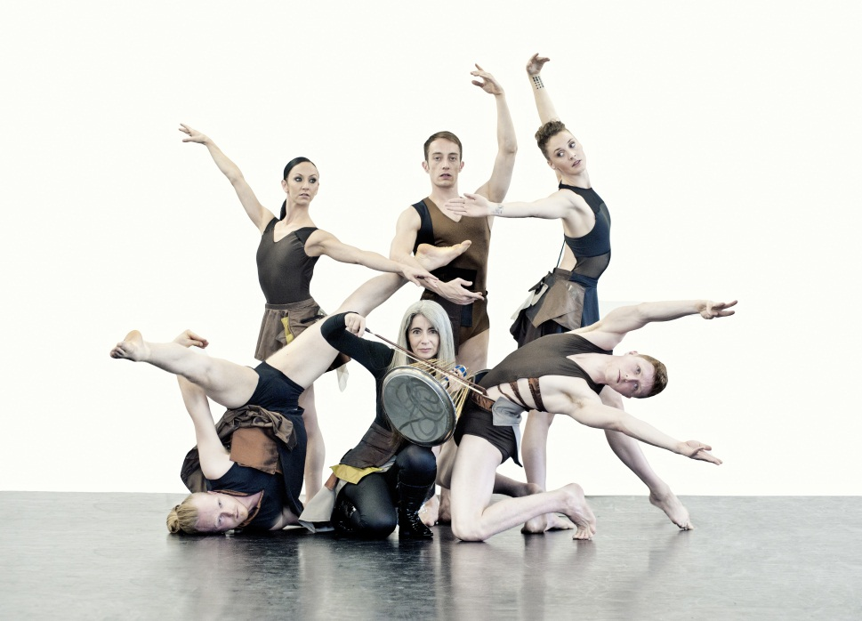
Marc Brew's juxtaposition of classical and contemporary movement styles is vital and compelling, a gorgeous weave of attractive physicality, thrillingly percussive soundscapes and a lighting design where fine golden rays spike through shadows to kiss the limbs that fleetingly cross their path. Exquisite.
This mood – primal, mystical, timeless – is generated from the moment Evelyn Glennie crouches over a drum in the semi-darkness and sends wonderfully insistent rhythms into the void. Her summons is answered: a male dancer emerges and, not unlike a tribal parley, the exchange of steps and balances begins. Glennie's own, intense body language soon adds in another dimension, especially when she moves among the dancers playing instruments that chime and shimmer against her pre-recorded score.
That she's truly immersed in the process is emphasised by her being costumed, like the five exhilarating performers, in sheeny brown fragments – think Vivienne Westwood for Peter Pan, and you'll appreciate her gumption, as well as her percussive panache in this very welcome Unlimited commission.
Before the interval, Brew's solo Remember When touched eloquently on aspects of his mobility before, and after, he became a wheelchair user. It's honest, unsentimental and expressive beyond words. The triple bill opened with Nocturne, a wry – often athletic, sometimes sensual – foray for two couples who may, or may not, be partners beyond this bedroom encounter ... What is not in doubt, however, is Brew's choreographic flair in this, his company's first showing.
Mary Brennan, Herald Scotland, Published on 29 October 2012
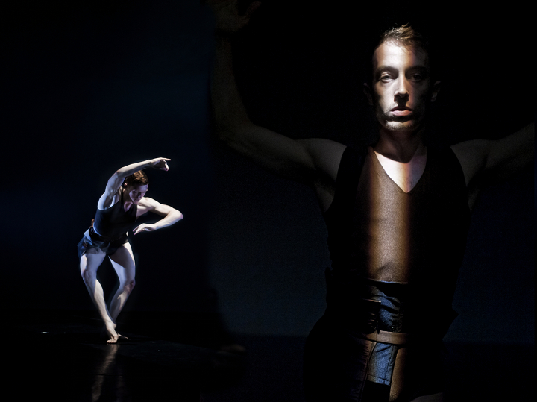
Having been the propulsive heartbeat at the centre of the Olympics opening ceremony, percussionist Evelyn Glennie adds decorative layers of sound to Marc Brew’s action-packed 25-minute dance piece, Fusional Fragments. The bedrock of the work is a series of solos, duets and trios performed with speed, agility and Olympian strength by five gladiatorial dancers against Philip Sheppard’s soundtrack of percussive electronica and vocals that switch from haunting wails to prayer-like mantras. Andy Hamer’s cubes and pyramids of golden light illuminate limbs and torsos in fluid fragments, while javelins of light thrust across the stage wall. In one sequence a man moves with loris-like elegance across a tightrope of light that recalls Michael Hulls’ razor-sharp lighting designs for Russell Maliphant.
And all the while, the extraordinarily charismatic figure of Glennie traverses the stage hammering out thunderous beats from a variety of percussion instruments, or coaxing the softest whispering sounds from steel brushed on metal, temple bells or turning Japanese with the plaintive bongs of a glass bell jar. Interacting with the dancers she resembles a pagan priestess, a sorceress of sound, her long hair waving in physical harmony with the dancers as she circles and weaves around and through them awakening them to life or sonically urging them to push the limits of their physicality to the edge as they extend their limbs and fold their torsos in a fierce drama reminiscent of Wayne McGregor’s best work. Part of the Unlimited project for the 2012 Cutural Olympiad celebrating deaf and disabled artists, this is mesmerising and exciting beyond belief.
Neil Norman, The Stage, Published Monday 3 September 2012

Nocturne
Performed with such a sense of immediacy and emotional engagement that I was deeply moved. Brew is also an astute choreographer putting as much thought into the small details as the overall composition.
Aimee Tsao, Dancetabs

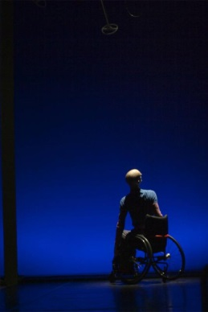
Remember When
Marc Brew knows exactly how to touch his audience in all the right places with his beautifully crafted and succinct solo.
Kelly Apter, The Scotsman

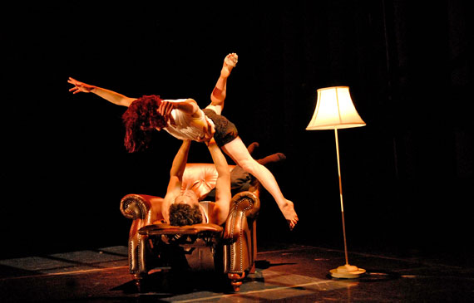
Full of Words (for Axis Dance Company)
Smart, witty drama
Rita Felciano, Dance View Times

Brew…has a keen eye for visually arresting moments.
The conversations are engrossing…a credit to Brew’s choreography and the intensity of the dancers.
Mary Ellen Hunt, San Francisco Chronicle

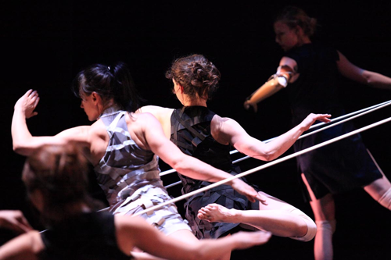
Parallel Lines (for Candoco)
Parallel Lines is…an elegant, pleasingly kinetic work
Lise Smith, Londondance.com
Technically brilliant, the connections were powerful in this piece by Marc, himself a top-notch choreographer.
Sophie Partridge, Disability Arts Online, 8 September 2012

