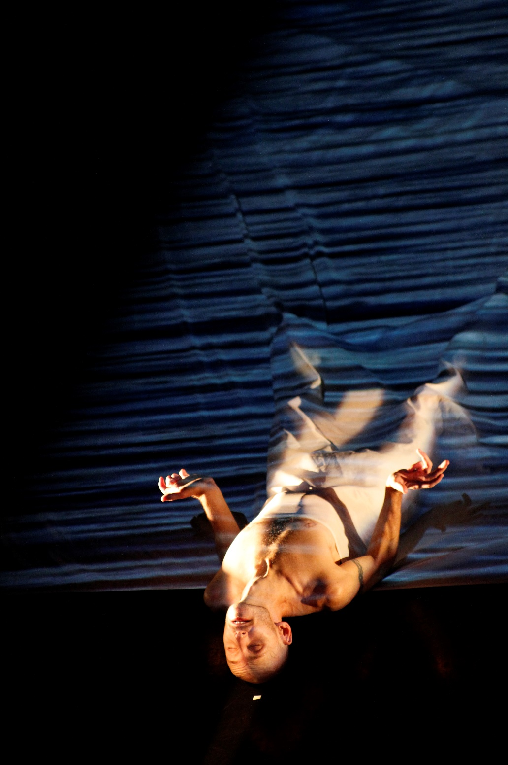

For Now, I am
Marketing Pack

For Now, I am Tour

For Now, I am 40 mins

Age rec: We recommend this programme for ages 12+ but welcome people of all ages.

Warnings: There are no specific warnings for this programme but please note that For Now, I am uses haze and Marc appears with a bare chest and legs

About Marc Brew, Artistic Director, Choreographer and Dancer:
Marc Brew is an Australian performer, director and choreographer. Now based in Glasgow, Marc’s work has been toured to critical acclaim across the world, his outdoor work (i)land being commissioned for the Glasgow 214 Cultural programme and Without Walls. Marc has also produced work for a number of high profile companies such as AXIS Dance Theatre (USA), Candoco Dance Company, Scottish Dance Theatre, Touch Compass (NZ), Amy Seiwert’s Imagery (USA), The London Contemporary Dance School and YDance. Marc has been presented with a Centenary Medal for Outstanding Contribution as a dancer and choreographer and in 2014 Marc was nominated for Outstanding Achievement in Performance (Individual) at the prestigious Isadora Duncan Awards for his solo piece Remember When.

About Marc Brew Company:
Marc Brew Company is committed to developing innovative collaborative work that interweaves a physicality derivative of strong contemporary dance technique. The choreographer employs the use of line and extension, with intricate folding, placement and re-placement. This complex use of the body fused with a very human content offers audiences a clear, intricate and emotive experience. The works created by the company can be thought of as a series of physical conversations, encounters and interventions that reflect what it is to be human.

The Work

Full Copy
(Please run any edits past Vicky / marketing@marcbrew.com)

Marc Brew Company
For Now, I am
Short Description max 50 words (no including company name or title)

Stripped back - for the first time since his car accident in 1997 - Brew creates an intimate new solo that engages directly with his body as it is now, exploring what it is to be broken, reborn, purified, and to reconcile being in the world in an entirely new way.

Long Description (no limit but best to keep it under 200 words)
Following on from Brew’s acclaimed Remember When which recalled his training and body as he knew it as an elite ballet dancer, For Now I am engages directly with his body as it is now, 18 years on since his life changing car accident, investigating and exposing his changed form.
Featuring Brew’s signature fierce physicality with tender expression to explore an emotional narrative in dance, a newly commissioned music score composed by Claire McCue and striking visual projections by Jamie Wardrop and an exquisite lighting design by Andy Hamer, For Now I am explores the journey of getting to know and learning to accept a changed body and new ways of living and performing.
Marc Brew Company creates work in collaboration with disabled and non-disabled artists, drawing on the unique physicality of each performer creating dance that is honest, unsentimental and recognisably human.

“Marc Brew's juxtaposition of classical and contemporary movement styles is vital and compelling” - Herald Scotland

Further Info

For Now, I am..

Creative Team
Concept and Choreography - Marc Brew
Design - Andy Hamer
Composer - Claire McCue
Projection Visuals – Jamie Wardrop
Creative/Rehearsal Director – Ruth Mills
Rigger – Will Roper
Production Manager – Joe Hornby
Producer/photographer – Susan Hay
Access Worker – Melanie Wilson
Music
Cello - Andrew Huggan
Piano - Claire McCue
Post edit/mix – Timothy Cooper
Recording – Bob Whitney
Water effects: David Thomas, Lisa Redfern, Mark Koenig, soundbible.com and freesfx.com

Creative Team biogs:
http://www.marcbrew.com/marc-brew-company/people/

For Now, I Am promo: http://vimeo.com/117259892
For Now, I Am promo embed code: <iframe src="//player.vimeo.com/video/117259892" width="500" height="281" frameborder="0" webkitallowfullscreen mozallowfullscreen allowfullscreen></iframe> <p><a href="http://vimeo.com/117259892">Marc Brew - For Now I am</a> from <a href="http://vimeo.com/user6316423">Marc Brew Company</a> on <a href="https://vimeo.com">Vimeo</a>.</p>
Please note you can edit the appearance of the embedded promo by clicking ‘share’ on the vimeo promo page.
For Now I am.. full length film:
FOR INFORMATION PURPOSES ONLY. NOT TO BE MADE PUBLIC
https://vimeo.com/132242040 (password ‘broken’)
Marc Brew talks about For Now, I am..
https://vimeo.com/128724626
For Now, I am.. (Audience responses)
https://youtu.be/IktvrcROREU
Rehearsal and Production Photos. Photographer Susan Hay
https://www.hightail.com/download/bXBacHBJYXlwM24wZXNUQw
For Now, I am.. press quotes and links to reviews
Absolutely breathtaking" Disability Arts Online
http://linkis.com/org.uk/Eo5IG
"A powerful and fascinating personal story of one man rediscovering his body, it’s a must watch” ★★★★ Edinburgh Festivals Magazine
http://www.edfestmag.com/for-now-i-am-2/
"A truly brave, beautifully choreographed and exquisitely staged dance work that needs to be seen. It will be the highlight of your Fringe dance programme." ★★★★★ TVBomb
http://www.tvbomb.co.uk/2015/08/for-now-i-am/
"Awe inspiring and thrilling are words that spring to mind... This performance will change your life!" ★★★★★ Mumble
http://mumbledance.net/2015/08/24/for-now-i-am/
"a powerful and touching work...captivating and strikingly honest" ★★★★ Down Stage Central
http://downstagecentre.com/the-dsc-team/rachel-elderkin/for-now-i-am/
“harrowing beauty and luminous, life-affirming spirit” ★★★★★ The Herald
http://www.heraldscotland.com/arts_ents/13215735.Dance_Reviews__An_Invitation_Purging_Suite__1_For_Now__I_am____at_Tramway/
“Mesmerising, phenomenal and haunting are only a small selection of worthy superlatives that can be used to describe Brew’s performance." ★★★★★ The Public Reviews
http://www.thepublicreviews.com/marc-brew-for-now-i-am-tramway-glasgow/
"Melancholic, yet passionate, it is a striking expression of narrative dance that is imaginative and thoughtful.” ★★★★ The List
http://www.acrossthearts.co.uk/news/artsblog/dance-review-purging-suite-1for-now-i-am/
“An emotionally-charged, personal journey of incredible beauty” ★★★★ Across The Arts
http://www.acrossthearts.co.uk/news/artsblog/dance-review-purging-suite-1for-now-i-am/
“Marc Brew is a sensitive, intelligent choreographer, and compelling performer is increasingly a matter of fact” ★★★★ The Scotsman
http://www.scotsman.com/what-s-on/theatre-comedy-dance/dance-reviews-tamsyn-russell-marc-brew-1-3788753

Other available materials
- Written Q&A blog from Marc specific to your venue
- Venue specific E-flyer (on request)
- We intend to ask members of the creative team for blogs relevant to their input into the work. Please let us know if there is anything specific that might speak to your audience.
- We can provide printed copies of the production shots for display in front of house areas on request.

Web and Social Media Links:
www.marcbrew.com
Facebook.com/marcbrewcompany
Twitter.com/marc_brew
Youtube.com/MarcBrewCompany
Vimeo.com/user6316423

Press Angles
Marc is happy to speak to members of the press about the work and the experiences that inspired it. Marc has had good press coverage in the past and the Scottish and UK dance journalists are familiar with his work. Marc would also be happy to be involved in a photocall where the schedule allows. Please contact Vicky marketing@marcbrew.com to discuss options.
It may also be possible to involve the wider creative team in press opportunities, please contact Vicky to discuss options.
______________________________________________
Marc and the company are open to looking at new opportunities to publicise the shows. If you have any marketing or publicity ideas that we can be involved in, please contact Vicky / marketing@marcbrew.com

