Contemporary Dance Master Class
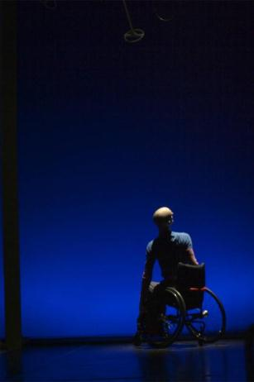 | Marc teaches a release-based technique class from his unique perspective. The class focuses on the continuance of energy flow in and around the body, through looking at length, line, placement and adaptation.  The last dance sequence is always a fun challenge taught from a wheelchair dancer’s perspective. Giving clear aims objectives of what is to be achieved the class participants find their own version of the sequence while still obtaining the correct timing, action, quality and pathway which unites all the various versions to be danced in small groups.
Marc teachers inclusively, ensuring his class work is accessible to all. This is achieved through feeding of information during the class in the following ways when required:
- Physical demonstration to show action, dynamics and placement
- Visual imagery to obtain the correct quality and physical sensation
- Audio description giving clear spacing, direction, pathways and timing.
- Hands on demonstration to enable correct posture and alignment.

- Choreographic workshop
- As a choreographer Marc seeks to challenge and be challenged. Providing the dancers with a new vocabulary that enhances their creativity, he tries to redefine expectations of physicality for all performers. With the use of set material derived from Marc’s own movement style and creative tasks, he directs the dancers in delivering his artistic flavour. His work is renowned for its tender, precise choreographic material that exemplifies the beauty of the moments shared between people, revealing the unusual and the inspiring in the everyday and the mundane.  Marc's extensive experience as a dancer and choreographer with a disability, working with disabled and non-disabled dancers means that he challenges performer’s expectations of their own limitations. In turn this challenges and inspires the dancers. Marc is committed to developing innovative collaborative work that interweaves a physicality derivative of strong contemporary dance technique. | - 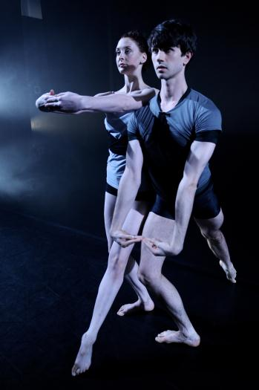
- The choreography employs the use of line and extension, with intricate folding, placement and re-placement. This complex use of the body fused with intimate narratives and domestic objects offers a clear, intricate and emotive experience. The work created can be thought of as a series of physical conversations, encounters and interventions that reflect what it is to be human.
- Contact Improvisation Workshop
- Marc guides the dancers through a loosely structured improvisation in a supportive environment where there is no wrong just an opportunity to offer, try, receive and share.
1. In pairs with one partner (mover) lying on their back with eyes closed we start with some body work – the second partner (do-er) offers a hands on approach bringing their partners awareness to their breath and the gentle contact offered (touch, rocking, stretching). Enabling the mover to receive and release any tension they may be holding unnecessarily.
- Listening through the points of contact offered from the do-er the mover will start to move into comfortable/uncomfortable positions supported by their partner. An exploration will then begin in response to the contact and gradually introducing weight - giving and receiving between the partnership.
- The duo then explore moving in and out of the floor and around the space in partnership - looking at the use of pressure of contact, space and levels.
- The next offering is to explore the principles of moving towards and away with different points of contact and body parts.
- As ones listening and body awareness have developed during the class the session will end with an open contact improvisation. A safe place for people to offer what they have learnt and investigated by entering and exiting the space - to be free and use the skills they have acquired.
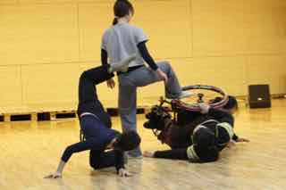 | 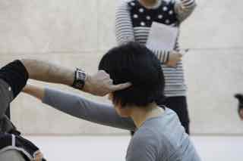

Creative Workshop
Bringing groups together in an inclusive environment Marc works together with participants to explore possibilities of movement and collaboration together through the use of various tasks and learning set material.
- Initially starting in a circle, creating a trusting and supportive environment to introduce each other.
- Movement games.
- Physical warm up.
- Exploring the use of space.
- Introduce contact with different body parts.
- Giving and supporting of weight – creating a platform, offer contact, shift, dissolve.
- Task 1 in small groups – Comic strips. Creating 4 to 8 still frames to tell a story and exploring the movement journey into and out of the still frames.
- Task 2 in pairs – Learn Marc’s set material to create your own solo that is put in conversation with partners to perform as a duet incorporating a point of contact, stillness, a repeat or retrograde and change of level.
- Show and offer supportive feedback.

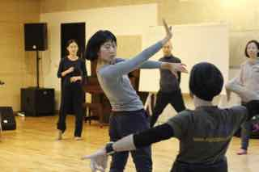 | 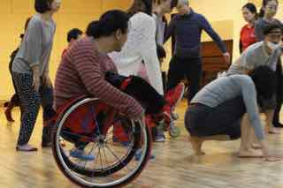

Teacher Training for Dancers, Professionals and Educators

Our teacher-training course is designed for teachers of dance and experienced artists interested in developing their teaching skills in leading physically integrated dance in an inclusive and supportive environment. We will be exploring the following areas:

- Open door policy - Removing any physical and emotional barriers that prevent people with disabilities from attending class
- Universal language and communication
- Exploring a variety of dance techniques, disciplines and approaches to teaching dance Stripping away the myths of integrated dance for a realistic approach to teaching inclusivity
- To challenge and be challenged - a mutual dialogue of respect between teacher student
- Body specificity - Working with different bodies to ensure all are challenged and learning
- Develop useful tools and skills to put into practice
- Ensuring best practice in physically integrated dance
- Build teachers confidence and set up a teachers network for future support
- Q&A time for discussion and feedback

